1. A shop stores customer id and their orders in a dictionary
How will you update the price of an existing item in a customer order.
Access the item using its key and assign a new value.
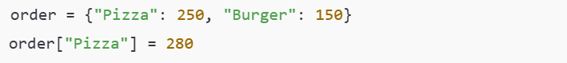

2. A customer adds a new item to an already placed order
Which dictionary operation will you use to modify the order.
Use key assignment to add a new key-value pair.

3. A restaurant wants to increase the price of all items in an order by 10
How can this be done using dictionary values.
Loop through the dictionary and update each value.
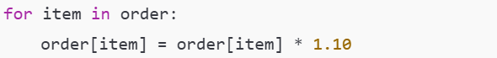

4. An order contains many items
How will you calculate the total bill using dictionary methods.
Use the values() method with sum().

5. A customer cancels one item from the order
How will you remove that item from the dictionary.
Use the pop() method with the item name.

6. A system needs to update multiple items in an order at the same time
Which dictionary method is suitable and why.
Use update() because it modifies multiple key-value pairs in one operation.

7. An item name may or may not exist in the order
How will you safely access its price without getting an error.
Use get() to avoid a KeyError.

8. A shop wants to check whether a customer has ordered Pizza
Which dictionary feature will you use.
Use the in keyword on dictionary keys.
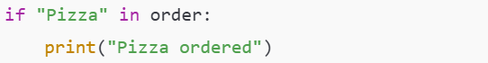

9. An order dictionary is empty
How can you add items dynamically to it.
Start with an empty dictionary and assign items.
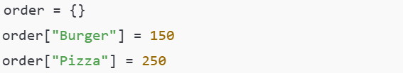

10. A restaurant stores orders for multiple customers
How will you loop through the dictionary to print each customer total bill.
Loop through customer dictionary and calculate totals.
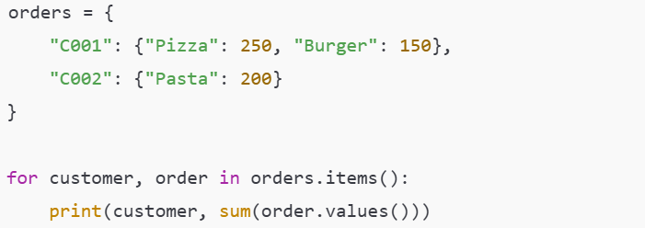

11. A food delivery app removes the last added item from an order
Which dictionary method will be used.
Use popitem().

12. A student record dictionary contains name age and marks
Which item will be removed when popitem is used and why.
It removes the last inserted key-value pair.
Removed item: "marks": 85
Reason: Dictionaries maintain insertion order (Python 3.7+).

13. A shop mistakenly added a wrong item price
How will you correct only that item without affecting others.
Update only that specific key.

14. A program needs to merge new order items with existing order
Which dictionary method will you use.
Use update().

15. A customer order dictionary is cleared after payment
Which dictionary method is used and what will be the result.
Use clear().
The dictionary becomes empty {} but still exists in memory.

